Remote Sensing and GIS Applications for Invasive Plant Species Management Across NASA Centers: A Feasibility Study
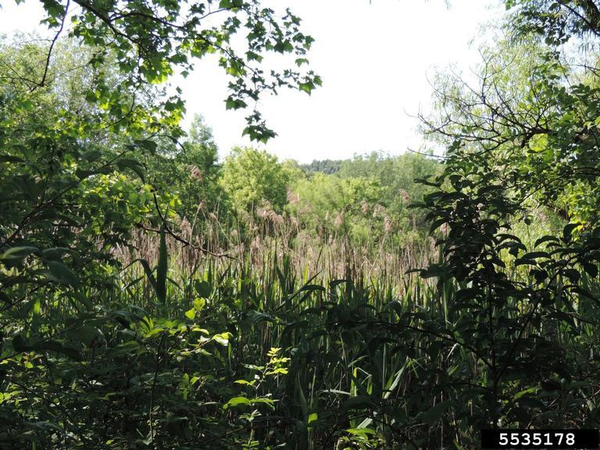
Common reed (Phragmites australis) Richard Gardner, Bugwood.org
Macey Hartmann¹, Nicholas Murdock¹, Jennifer Bailey²
¹National Aeronautics and Space Administration, Environmental Management Division. ²National Aeronautics and Space Administration Environmental and Medical Contract.

Executive Summary
Invasive non-native plant species (INPS) are species introduced from other countries or regions of the United States that threaten native plants and animals by altering the composition, structure, and function of native ecosystems. The heightened concern for INPS is due to the potential impact of invasive species on NASA missions, fire hazards, and the loss of habitat, and major threats to health and abundance of the native plant and animal populations, especially rare, threatened, and endangered species. INPS are often mitigated through mechanical and chemical control, however, some INPS have developed resistance to these methods. These issues demonstrate the need for an integrated approach to invasive species management involving early detection through monitoring. Monitoring INPS is crucial for implementing effective and cost-efficient management strategies before invasive non-native species (INPS) become widespread and cause significant ecological and economic damage, damages that already cost the United States more than $21 billion annually in economic and health-related impacts. Many NASA Centers identify a high to moderate level of concern for INPS on their grounds, with some Centers even identifying INPS as one of the most important management issues they face, but do not have standardized or consistent monitoring or mitigation practices. Current monitoring approaches include professional field surveys, citizen science programs, and advanced technologies like remote sensing and GIS. However, field surveys are time-intensive, costly, and may include difficult-to-access areas. Furthermore, some invasive species demand sophisticated combinations of control strategies implemented across multiple growing seasons. Staying current with the newest available scientific literature and using GIS and remote sensing is essential to provide effective and efficient control measures. GIS and remote sensing allow for large-area coverage of vast areas that would be impractical for on-the-ground surveys, access to remote areas, quantification and analysis of imagery, a comprehensive view throughout time, early detection capabilities, and resource optimization through cost-effectiveness and reduced field time. This feasibility study analyzes the practicality and viability of using remote sensing and GIS analysis to create effective control methods to manage invasive species across NASA centers. Initial findings from this feasibility study indicate that several NASA centers show high potential for implementing remote sensing and GIS for INPS management, particularly Wallops Flight Facility, Glenn Research Center, Kennedy Space Center, and Marshall Space Flight Center. These centers combine high invasive species risk with suitable land cover and available imagery resources. Centers with established GIS capabilities, like Johnson Space Center, could serve as an example for implementation across NASA. Possible issues identified include varying levels of available resources across centers, technical expertise limitations for imagery interpretation, challenges in spectral differentiation between similar native and invasive species, and the need for seasonal monitoring due to phenological differences in plant visibility. Additionally, the diversity of landscapes across NASA centers, from coastal wetlands to arid deserts, will require customized detection approaches rather than a standardized solution. Budget constraints, competing operational priorities, and jurisdictional complexities present further challenges to implementation that will need to be addressed for successful adoption across the NASA network.

Methods
A review of NASA’s Natural Resource Management Plans (NRMP), NASA Invasive Species Fact Sheets, and NASA Environmental Resource Documents and Environmental Resource Tools, interviewing NASA Natural Resource Management team members from 9 NASA centers, analyzing relevant research papers and websites, and examining available optical imagery produced qualitative and quantitative data.

Scoring
Centers were scored (1-5) along various categories (invasive species risk, land cover, available imagery, and resources ). The scores ranged from 1 to 5, with 1 being low and 5 being high. These scores were analyzed in combination within an applicability grid to determine a Center’s overall INPS Remote Sensing feasibility score. For example, a center with a very high risk of invasive species, a large amount of suitable land cover, readily available and interpretable imagery, and a large amount of resources would receive a score of 5 in each section, adding up to the highest feasibility score of 20. This method could still produce the same summed score for centers whose INPS risk is vastly different, so the INPS risk category was weighted by a multiple of three to produce a weighted feasibility score accurately reflecting center need.
After weighting, the same center would have an overall feasibility score of 30, which is equivalent to a center with 5s in each section. The higher the overall feasibility score, the fewer obstacles to the implementation of INPS management via remote sensing exist at the center.

Color Scoring
The weighted score was then given a corresponding color category, with the color red given to scores from 0-10 correlating to a low feasibility, the color yellow given to scores from 11-20 correlating to a medium feasibility, and the color green given to scores from 21-30 correlating to a high feasibility. The visual color allows readers to quickly determine a Center's feasibility category, with the option to look at the numbered score breakdown for more granular detail. Limitations to this study include, but are not limited to, a subjective scoring system, which could introduce bias in the feasibility scores, and potential interview bias. Additionally, remote sensing and GIS methods reviewed may not be applicable for all vegetation types across the U.S. Finally, the feasibility study analyzes potential approaches but will not include data on implementation or effectiveness of the proposed management strategies.

Visual
Center | Invasive Species Risk | Land Cover | Available Imagery | Resources | Feasibility Score | Weighted Score (invasive species risk x 3)
Wallops Flight Facility | 5 | 5 | 5 | 3 | 18 | 28
Glenn Research Center | 5 | 5 | 5 | 1 | 16 | 26
Kennedy Space Center | 5 | 4 | 4 | 3 | 16 | 26
Marshall Space Flight Center | 5 | 4 | 3 | 3 | 15 | 25
Ames Research Center | 5 | 3 | 4 | 1 | 13 | 23
Johnson Space Center | 3 | 5 | 5 | 3 | 16 | 22
Stennis Space Center | 1 | 5 | 5 | 4 | 15 | 17
White Sands Test Facility | 1 | 2 | 2 | 3 | 8 | 12
Armstrong Flight Research Center | 1 | 2 | 1 | 1 | 5 | 8

Wallops Flight Facility
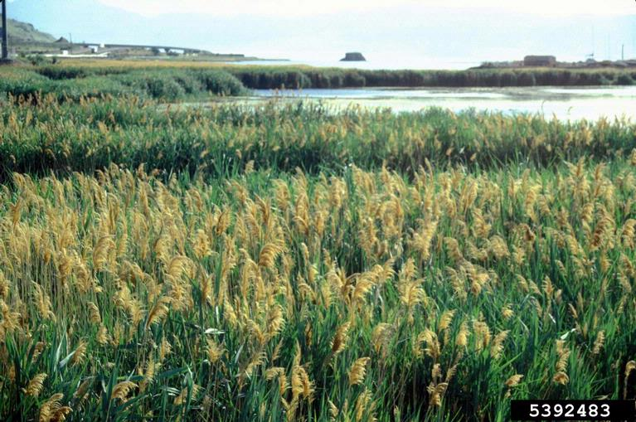
Common reed (Phragmites australis) John M. Randall, The Nature Conservancy, Bugwood.org
Center | Invasive Species Risk | Land Cover | Available Imagery | Resources | Feasibility Score | Weighted Score (invasive species risk x 3)
Wallops Flight Facility | 5 | 5 | 5 | 3 | 18 | 28
Wallops Flight Facility has a high weighted feasibility score of 28, indicating strong candidacy for GIS and remote sensing implementation to manage INPS.
Background:
Located in northern Accomack County on the Eastern Shore of Virginia, Wallops Flight Facility (WFF) is composed of three separate land areas (the Main Base, Mainland, and Wallops Island). The Main Base (approximately 2,230 acres) and the Mainland (100 acres) are bordered by extensive marshland, while Wallops Island (approximately 4,200 acres) is covered by marshland on the entire western approach to the island. The Main Base, the Mainland, and Wallops Island all contain a high level of common reed (Phragmites australis) and mile-a-minute (Persicaria perfoliata). Wallops Island additionally contains sericea lespedeza (Lespedeza cuneata), russian thistle (Salsola tragus), and clovers (Trifolium repens). Due to historic disturbance, land use history, and landscaping practices at all WFF locations, INPS has colonized a large area of the facilities and has a high level of concern at the center. INPS such as common reed impact Wallops Space Flight Center by causing environmental damage, shading native species, and presenting a fire hazard due to the flammability of standing vegetation. NASA works with the Virginia Department of Conservation and Recreation to map, control, and monitor common reed at WFF as part of an ongoing project. Over 130 hectares of common reed on Wallops Island have been aerially treated with herbicide. Additionally, WFF has developed a Phragmites Control Plan that consists of a combination of aerial and hand application of herbicide, controlled burning, mowing of small infestations, special considerations for operating heavy equipment in common reed-infested areas, annual monitoring, and reporting of common reed growth. In 2007 and 2008, researchers used a combination of field surveys and aerial photo analysis to determine the extent of INPS at WFF. They found 320 hectares of INPS, with common reed making up 88 percent of this area (278 hectares on Wallops Island, 0.4 hectares on the Mainland, and 4.5 hectares at Main Base). A subsequent (2011) Natural Heritage Survey of North Wallops Island conducted by the Natural Heritage Division of the Virginia Department of Conservation and Recreation reached similar findings.
Scoring:
Discussions with staff at WFF revealed interest in remote sensing and GIS technology to identify heavily infested areas and track the historical spread of INPS on Wallops Island, allowing them to analyze changes in percent coverage over time. WFF scored a 5 for invasive species risk. With the center covering approximately 6,530 acres, WFF scored a 5 for land cover. WFF scored a 5 for available imagery due to the availability of previous aerial surveys and an Environmental Resource Tool. WFF scored a 3 for resources. While there is an interest in surveying and employing new technologies, eradication of INPS is only currently available in mission-critical areas or areas at risk of fire. These four scores added to a feasibility score of 18 and a weighted feasibility score of 28, WFF falls into the high feasibility score category with the correlated color green. The high feasibility score reveals that Wallops Flight Facility may be a strong candidate for the implementation of remote sensing and GIS analysis to create effective control methods to manage INPS at the center.

Armstrong Flight Research Center
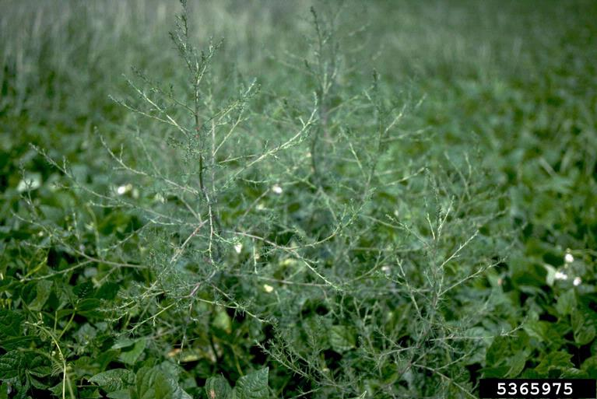
Russian thistle (Salsola tragus), Howard F. Schwartz, Colorado State University, Bugwood.org
Center | Invasive Species Risk | Land Cover | Available Imagery | Resources | Feasibility Score | Weighted Score (invasive species risk x 3)
Armstrong Flight Research Center | 1 | 2 | 1 | 1 | 5 | 8
Armstrong Flight Research Center has a low weighted feasibility score of 8, indicating low candidacy for GIS and remote sensing implementation to manage INPS.
Background:
Located in California’s Western Mojave Desert at Edwards Air Force Base, Armstrong Flight Research Center (AFRC) features an arid landscape with sparse desert vegetation. Although AFRC sits on 300,000 acres of remote land, much of the acreage is under the jurisdiction of Edwards Air Force Base. Some INPS present at AFRC include Russian thistle (Salsola tragus) and mustard plants (Brassica juncea). INPS impacts AFRC by endangering the threatened desert tortoise (Gopherus agassizii) by directly and indirectly altering their habitats, reducing food sources, and increasing competition for resources. The issue of INPS is of low concern for AFRC, with most problems caused by road maintenance. Road maintenance vehicles that have come in contact with INPS, such as mustard plants, may cause ground disturbance and spread seeds. INPS mainly occur along the road at AFRC. Edwards contractors conduct treatment through grading and herbicides.
Scoring:
Discussions with staff at AFRC revealed interest in using remote sensing and GIS technology for INPS, however, there was little need or benefit identified. With a low concern for INPS, AFRC scored a 1 for invasive species risk. The center sits on 300,000 acres of remote land of sparse vegetation and differing jurisdictional boundaries; thus, AFRC scored a 2 for land cover. With no Environmental Resource Tool, AFRC scored a 1 for available imagery. With much of the treatment of INPS being conducted by Edwards Air Force Base, AFRC scored a 1 for resources. These four scores added to a feasibility score of 5 and a weighted feasibility score of 8. AFRC falls into the low feasibility score category with the correlated color red. Thus, Armstrong Flight Research Center is not a strong candidate for the implementation of remote sensing and GIS analysis to manage INPS at the center.

Johnson Space Center
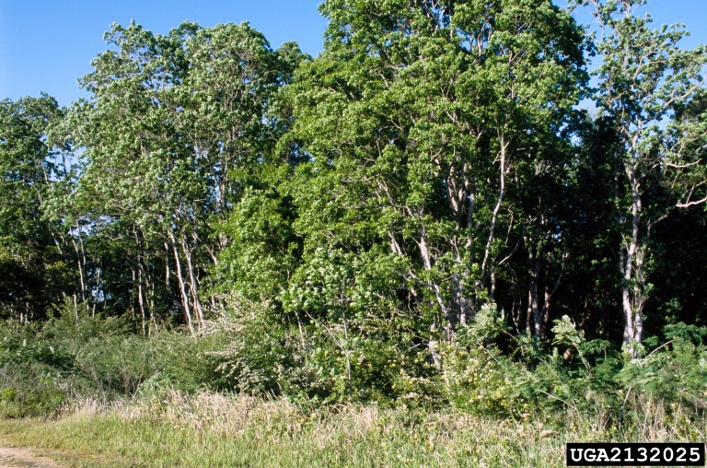
Chinese tallowtree (Triadica sebifera), James H. Miller, USDA Forest Service, Bugwood.org
Center | Invasive Species Risk | Land Cover | Available Imagery | Resources | Feasibility Score | Weighted Score (invasive species risk x 3)
Johnson Space Center | 3 | 5 | 5 | 3 | 16 | 22
Johnson Space Center has a high weighted feasibility score of 28, indicating strong candidacy for GIS and remote sensing implementation to manage INPS.
Background:
Located in Clear Lake, Texas, Johnson Space Center (JSC) sits in a flat coastal plain with subtropical vegetation, a humid climate, and wetlands. JSC has three main sites (Main Campus, Sonny Carter Training Facility/Neutral Buoyancy Lab, and Ellington Field Joint Reserve Base) covering almost 1,700 acres. The level of concern for INPS at JSC is moderate. JSC contains dozens of known INPS, with the most pervasive being Chinese tallow (Triadica sebifera) and Johnson grass (Sorghum halepense). All prairie areas are mowed once a year to control the invasion of woody species, and facilities remove invasive species and incorporate best practices to preserve or improve the native plant communities, and herbicide spraying occurs on a small scale. However, control efforts are limited as there is no specific contract in place to address INPS at JSC. A 2014 wetland restoration effort conducted under USACE Nationwide Permit 27 removed Chinese tallow (Triadica sebifera) trees along with other invasive plants using mechanical methods and herbicide application, but this area has since been reinvaded by Chinese tallow. Options for retreatment are being explored, and JSC is developing education materials on the importance of controlling INPS. Remote sensing and GIS technologies have been previously used to monitor INPS at JSC.
Scoring:
Discussions with staff at JSC revealed interest in continuing and expanding the remote sensing and GIS technology to track the spread of INPS. With a moderate concern for INPS, JSC scored a 3 for invasive species risk. With the center covering approximately 1,700 acres, JSC scored a 5 for land cover. With previous aerial surveys and analysis of INPS movement using remote sensing and GIS, JSC scored a 5 for available imagery. Although JSC has experience in using GIS and remote sensing for INPS, the competing land use priorities at the center led to JSC scoring a 3 on resources. These four scores added to a feasibility score of 16 and a weighted feasibility score of 22. JSC falls into the high feasibility score category with the correlated color green. The high feasibility score reveals that Johnson Space Center may be a strong candidate for the continuation and expansion of remote sensing and GIS analysis for INPS management at the center.

Glenn Research Center
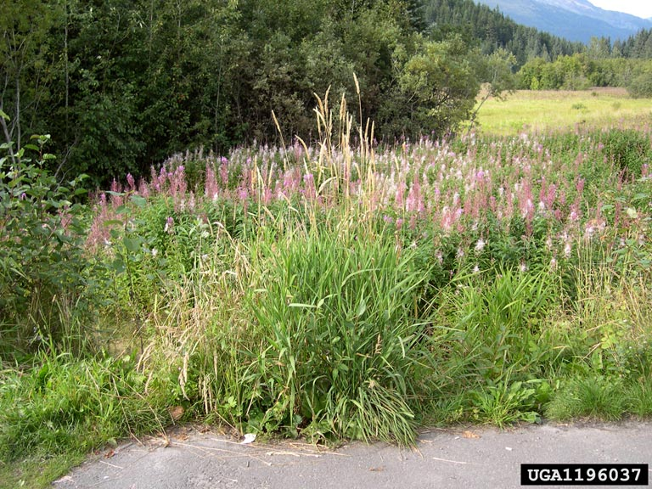
Reed Canary Grass (Phalaris arundinacea), Tom Heutte, USDA Forest Service, Bugwood.org
Center | Invasive Species Risk | Land Cover | Available Imagery | Resources | Feasibility Score | Weighted Score (invasive species risk x 3)
Glenn Research Center | 5 | 5 | 5 | 1 | 16 | 26
Glenn Research Center has a high weighted feasibility score of 26, indicating strong candidacy for GIS and remote sensing implementation to manage INPS.
Background:
Located in Cleveland, Ohio, Glenn Research Center’s main campus, Lewis Field (GRC-LF), sits near the southern shore of Lake Erie in a mixed urban-industrial area with some forested patches and parklands nearby. GRC's other location, the Neil Armstrong Test Facility (LF-ATF), sits on 6,400 acres in Sandusky, Ohio, on a primarily undeveloped landscape. Due to the threat of wetland degradation and encroachment in rare habitats posed by competition and shading from INPS, GRC has a high level of concern for INPS, especially at the Neil Armstrong Test Facility, where undeveloped land is easy for INPS to encroach on. Species of high concern include reed canary grass (Phalaris arundinacea), common reed, multiflora rose (Rosa multiflora), narrow-leaved cattail (Typha angustifolia), hybrid cattail (Typha xglauca), purple loosestrife (Lythrum salicaria), and Eurasian water milfoil (Myriophyllum spicatum). INPS such as common reed, narrow-leaved cattail, and reed canary grass pose a risk to GRC’s wetland areas and rare species that exist in wetland swales. Other INPS, such as Asian honeysuckle (Lonicera japonica) and multiflora rose, have been increasing and are abundant where canopy gaps were created. Multiflora rose can outcompete tree seedlings, preventing the recovery of the forest canopy with native species. Current INPS mitigation techniques include brush removal and herbicide application. Previously, prescribed burning was used for INPS control with a robust annual fire regime, preventing woody INPS like autumn olive (Elaeagnus umbellata) from invading prairie and other open areas that contain populations of rare plants; however, prescribed fire has not been used for mitigation purposes since the fall of 2022.
Scoring:
Discussion with staff at GRC revealed interest in using remote sensing and GIS technology for INPS, especially at the GRC-ATF.. With a high concern for INPS, GRC scored a 5 for invasive species risk. With the Neil Armstrong Test Facility sitting on 6,400 acres of encroachable land, GRC scored a 5 for land cover. GRC scored a 5 for available imagery due to the availability of previous aerial surveys and an available Environmental Resource Tool. GRC scored a 2 for resources. While there is an interest in surveying and employing new technologies, deferred maintenance, as well as budget and regulatory constraints, restrict the available resources. These four scores added to a feasibility score of 16 and a weighted feasibility score of 26.. With a weighted feasibility score of 26, GRC falls into the high feasibility score category with the correlated color green. The high feasibility score reveals that Glenn Research Center, especially the Neil Armstrong Test Facility, may be a strong candidate for the implementation of remote sensing and GIS analysis to manage INPS at the center.

Stennis Space Center
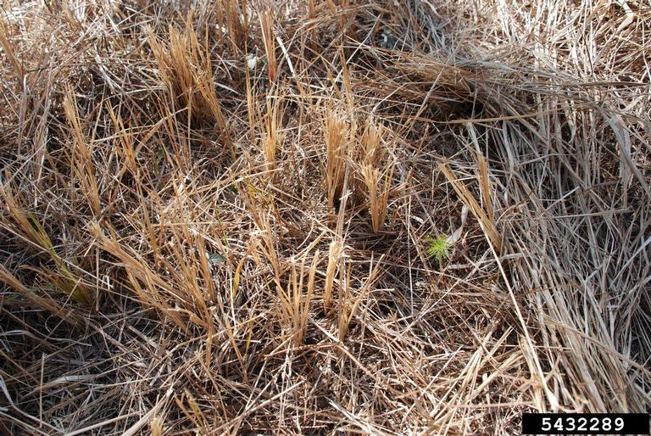
Cogongrass (Imperata cylindrica), Nancy Loewenstein, Auburn University, Bugwood.org

Center | Invasive Species Risk | Land Cover | Available Imagery | Resources | Feasibility Score | Weighted Score (invasive species risk x 3)
Stennis Space Center | 1 | 5 | 5 | 4 | 15 | 17
Stennis Space Center has a moderate weighted feasibility score of 17, indicating possible candidacy for GIS and remote sensing implementation to manage INPS.
Background:
Located in Hancock County, Mississippi, Stennis Space Center (SSC) is positioned among numerous waterways with a landscape featuring a mix of southern pine forests, bayous, and swamps. SSC encompasses over 138,000 acres with a 13,800-acre “fee” area that contains all facilities and test structures, and a 125,000-acre buffer zone ensuring that the testing of rocket engines has a minimal impact on the surrounding communities. At SSC, INPS are widely distributed and mixed with native species, while others are present as dense populations and monocultures. Beyond the possibility of fire, INPS poses a low risk to SSC because they are not present in mission-critical areas and do not affect center duties. INPS at SSC include Chinese tallow (Triadica sebifera), cogon grass (Imperata cylindrica), water hyacinth (Eichhornia crassipes), giant salvinia (Salvinia molesta), and torpedo grass (Panicum repens). INPS mitigation techniques at SSC include herbicide application around buildings, maintained areas, and priority areas.
Scoring
Discussions with staff at SSC revealed interest in using remote sensing and GIS technology for INPS research and mitigation. With a low concern for INPS, SSC scored a 1 for invasive species risk. With SSC encompassing over 138,000 acres of mostly undeveloped land, SSC scored a 5 for land cover. SSC scored a 5 for available imagery due to the availability of previous aerial surveys and an available Environmental Resource Tool. SSC scored a 4 for resources as they have an active GIS group and active spraying occurring. These four scores added to a feasibility score of 15 and a weighted feasibility score of 17. SSC falls into the moderate feasibility score category with the correlated color yellow. The moderate feasibility score reveals that Stennis Space Center may be a lower-priority candidate for the implementation of remote sensing and GIS analysis to manage INPS at the center.

Ames Research Center
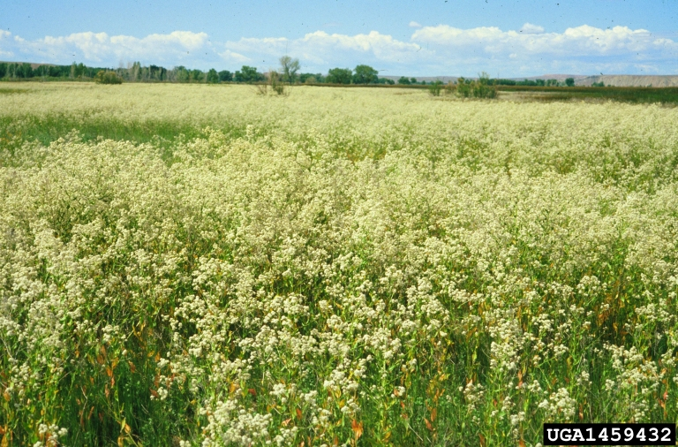
Perennial pepperweed (Lepidium latifolium), Steve Dewey, Utah State University, Bugwood.org
Center | Invasive Species Risk | Land Cover | Available Imagery | Resources | Feasibility Score | Weighted Score (invasive species risk x 3)
Ames Research Center | 5 | 3 | 4 | 1 | 13 | 23
Ames Research Center has a high weighted feasibility score of 23, indicating strong candidacy for GIS and remote sensing implementation to manage INPS.
Background:
Located in Mountain View, California, Ames Research Center (ARC) sits on Moffett Federal Airfield and features a mix of 220 acres of urban development and wetlands. Due to the threat of wetland degradation and encroachment of native habitats, especially those with native pickleweed (Salicornia virginica), ARC has a high level of concern for INPS. Species of high concern include perennial pepperweed (Lepidium latifolium), pampas grass (Cortaderia selloana), and giant reed (Arundo donax). These highly concerning INPS are mainly located in the more remote wetland areas. In the last few years, the pepperweed overtook the western marsh, completely overstorying the native pickleweed plant, choking it out of light during the growth season, and completely covering the marshland. Some of the INPS have been mechanically removed from the center, however, the plant’s extensive rhizome networks will allow for stalk regrowth and continued expansion. ARC has mitigation plans to prevent the introduction of new invasive species and to avoid the spread of existing invasives through native plantings, weed-free landscaping materials and soil, equipment washing prior to use in sensitive areas, and eradication of any invasives discovered in construction areas. However, no current efforts by NASA or its tenants are underway to reduce invasive non-native plants already at ARC.
Scoring:
Discussions with staff at ARC revealed interest in remote sensing and GIS technology, especially to map the center’s invasive pepperweed patch. ARC scored a 5 for invasive species risk. With the center covering 220 acres and the INPS inhabiting patches of wetlands removed from daily interaction with staff and vehicles, ARC scored a 3 for land cover. ARC scored a 4 for available imagery as they have high-fidelity imagery habitat maps of the marshes, but do not have an Environmental Resource Tool. ARC scored a 1 for resources. While there is an interest in employing new technologies, there is no regulatory driver, funding, or specific project to manage and combat INPS at ARC. These four scores added to a feasibility score of 13 and a weighted feasibility score of 23. ARC falls into the high feasibility score category with the correlated color green. The high feasibility score reveals that Ames Research Center may be a strong candidate for the implementation of remote sensing and GIS analysis to create effective control methods to manage INPS at the center if provided with the resources to do so.

Kennedy Space Center
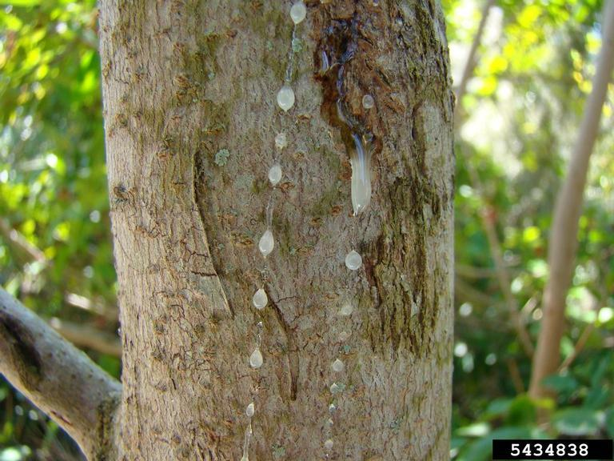
Brazilian peppertree (Schinus terebinthifolia), Rebekah D. Wallace, University of Georgia, Bugwood.org
Center | Invasive Species Risk | Land Cover | Available Imagery | Resources | Feasibility Score | Weighted Score (invasive species risk x 3)
Kennedy Space Center | 5 | 4 | 4 | 3 | 16 | 26
Kennedy Space Center has a high weighted feasibility score of 26, indicating strong candidacy for GIS and remote sensing implementation to manage INPS.
Background:
Located on Florida’s Merritt Island, Kennedy Space Center (KSC) occupies 140,000 acres of coastal environment with a landscape featuring extensive wetlands, coastal scrub, and mangrove estuaries. KSC is partially contained within the Merritt Island National Wildlife Refuge, and the refuge oversees the management of INPS. INPS are identified as one of the most important management issues facing the refuge, with over 200 INPS on site. This reveals a high level of concern for INPS at KSC, with the biggest problem species identified as Brazilian peppertree (Schinus terebinthifolia), Cogon grass (Imperata cylindrica), and Australian pine (Casuarina equisetifolia). INPS are of concern to KSC due to their potential to displace vegetation that is more desirable. For example, a citrus grove at the center was overrun by Brazilian peppertree, creating an area with little value for wildlife. No official monitoring for invasive non-native plants on KSC has occurred. However, mechanical and chemical control is conducted as requested. KSC has the goal of treating all active disturbed remediation project areas with herbicide to reduce INPS.
Scoring:
Discussions with staff at KSC revealed interest and previous use of remote sensing and GIS technology for INPS research and mitigation. With a high concern for INPS, KSC scored a 5 for invasive species risk. With KSC covering a large acreage and containing specific mitigation areas, KSC scored a 4 for land cover. KSC scored a 4 for available imagery as they have available maps with a specific layer for Brazilian peppertree, yet do not have an Environmental Resource Tool. KSC scored a 3 for resources. While KSC has an established GIS and remote sensing program with specific INPS mitigation areas, they are limited by funding resources. These four scores added to a feasibility score of 16 and a weighted feasibility score of 26. KSC falls into the high feasibility score category with the correlated color green. The high feasibility score reveals that Kennedy Space Center may be a high-priority candidate for the implementation of remote sensing and GIS analysis to identify high areas of INPS risk at the center.

White Sands Test Facility
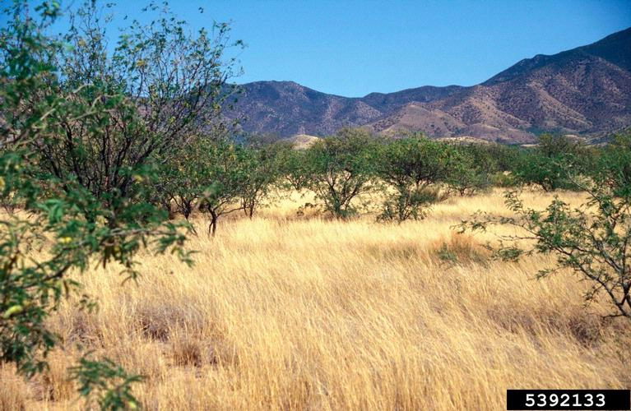
Lehmann lovegrass (Eragrostis lehmanniana), John M. Randall, The Nature Conservancy, Bugwood.org
Center | Invasive Species Risk | Land Cover | Available Imagery | Resources | Feasibility Score | Weighted Score (invasive species risk x 3)
White Sands Test Facility | 1 | 2 | 2 | 3 | 8 | 12
White Sands Test Facility has a moderate weighted feasibility score of 17, indicating possible candidacy for GIS and remote sensing implementation to manage INPS.
Background:
Located in the Organ Mountains near Las Cruces, New Mexico, White Sands Test Facility (WSTF) sits in 60,000 acres of high desert landscape with arid mountains and sparse vegetation. Though scoring reveals moderate INPS risk, arid conditions at White Sands can represent an obstacle to invasive species colonization. The INPS present at WSTF include salt cedar (Tamarix ramosissima) and Lehmann lovegrass (Eragrostis lehmanniana). Salt cedar has become less of a concern as it has dissipated with the removal of sewage lagoons and was knocked back by Tamarisk beetles (Diorhabda carinulata) released for biological control. Lehmann lovegrass is more concerning as it spreads easily by the movement of facility vehicles, and if it becomes widely spread, it may have the potential to impact mission. Lehmann lovegrass has mainly grown in the remote eastern part of the center, with a small part in the industrial area. WSTF does not actively manage INPS. However, volunteer efforts to mechanically remove Lehmann lovegrass before seeding occur occasionally, but are insufficient to address the problem. Also, efforts are made to educate facility personnel on avoiding activities in infested areas and cleaning and evaluating construction materials before beginning a new project.
Scoring:
Discussions with staff at WSTF revealed interest in using remote sensing and GIS technology for INPS. WSTF scored a 1 for invasive species risk. The center sits on 60,000 acres with INPS occupying remote areas and encroaching on industrial land, yet not near any test areas, leading to a score of 2 for land cover. WSTF scored a 2 for available imagery. The center has accurate GIS imagery, however, it is from over 10 years ago and contains no Environmental Resource Tool. WSTF scored a 3 for resources. While WSTF has an established GIS program, the center is limited by funding resources. These four scores added to a feasibility score of 8 and a weighted feasibility score of 12. With a weighted feasibility score of 12, WSTF falls into the moderate feasibility score category with the correlated color yellow. Thus, White Sands Test Facility may be a lower-priority candidate for the implementation of remote sensing and GIS analysis to manage INPS at the center.

Marshall Space Flight Center
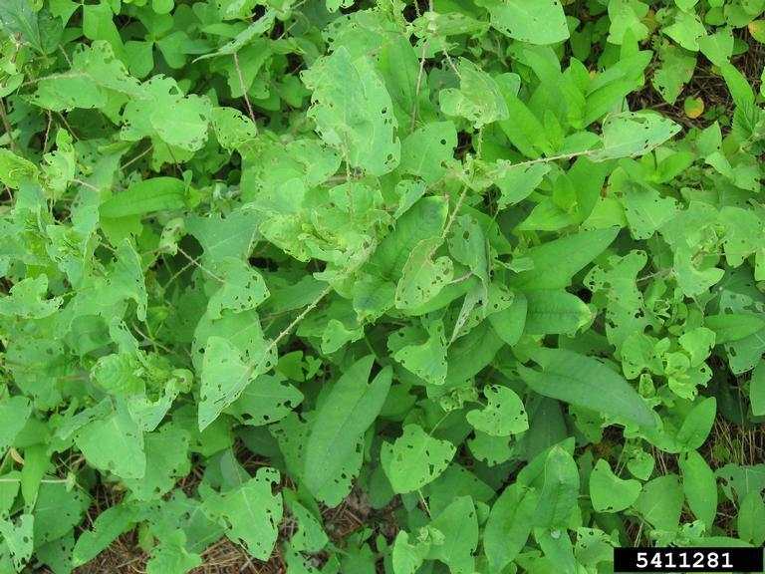
Mile-a-minute (Persicaria perfoliata), Ellen Lake, University of Delaware, Bugwood.org
Center | Invasive Species Risk | Land Cover | Available Imagery | Resources | Feasibility Score | Weighted Score (invasive species risk x 3)
Marshall Space Flight Center | 5 | 4 | 3 | 3 | 15 | 25
Marshall Space Flight Center has a high weighted feasibility score of 25, indicating strong candidacy for GIS and remote sensing implementation to manage INPS.
Background:
Marshall Space Flight Center (MSFC) is located within the Redstone Arsenal, a United States Army base adjacent to Huntsville, Alabama, in the Wheeler National Wildlife Refuge. Historically, INPS at MSFC has been mitigated by the United States Army. Although INPS are present at the center, many of them are of low risk to mission and safety at MSFC, as they are often found at forest boundaries. These low-risk species include Chinese privet (Ligustrum sinese), Bradford pear trees (Pyrus calleryana), tree of heaven (Ailanthus altissima), and Persian silk tree (Albizia julibrissin). MSFC keeps these low-risk species under observation, but they are not managed. However, due to its larger spread and high potential to displace more desirable vegetation, mile-a-minute (Persicaria perfoliata) is of high risk to MSFC. Within the 40,000 acres of Redstone Arsenal, mile-a-minute is present in the north area of MSFC, by the shipping and receiving facility, and close to a dangerous testing area. The United States Army no longer sprays mile-a-minute on a regular basis, and there is no active management of the species; however, mile-a-minute is cut back when the testing area gets overgrown. Ecological surveys have been conducted at MSFC in 1994, 2006, 2010, and 2015, and forestry management activities have documented INPS; however, no formal quantitative surveys of INPS coverage have been conducted.
Scoring:
Discussions with staff at MSFC revealed interest in using remote sensing and GIS to help the center efficiently use resources to solve problems. With a high concern for mile-a-minute, MSFC scored a 5 for invasive species risk. The center sits on 40,000 acres with INPS occupying remote areas, potential leasing areas, and testing areas, leading to a score of 4 for land cover. MSFC scored a 3 for available imagery as the center receives imagery every few years (most recently in 2024), but does not have an Environmental Resource Tool. MSFC scored a 3 for resources, as their INPS resources have historically been dependent on decisions from the United States Army. Mile-a-minute is easily visible on aerial imagery, and the center has previously considered using GIS and remote sensing to monitor INPS, but was limited by data availability and competing priorities. Although the high-risk INPS mile-a-minute is easy to spot with imagery, the lower-risk INPS, such as Chinese privet and tree of heaven, only bloom at specific times and are hard to find on aerial imagery due to a lack of resolution. The four scores added to a feasibility score of 15 and a weighted feasibility score of 25. MSFC falls into the high feasibility score category with the correlated color green. Thus, Marshall Space Flight Center may be a strong candidate for the implementation of remote sensing and GIS analysis to manage mile-a-minute at the center.

Challenges
This study was limited by multiple challenges. Limitations to this study include the following: potential subjectivity in the scoring system, potential interview bias, limitations to remote sensing and GIS data acquisition, and scope constraints.
Subjectivity in the scoring system was especially present in the land cover assessment. The land cover category was challenging to score accurately, as detailed vegetation mapping and information about the abundance of INPS land cover in comparison to total center land cover were not available at all centers. This data gap further demonstrates the need for remote sensing, which could provide this missing information.
The resources category was also challenging to score accurately, as resource availability can change on a yearly basis due to funding cycles, changing administrative priorities, and staffing changes. Furthermore, several centers, such as Marshall Space Flight Center and Armstrong Flight Research Center, rely on other agencies such as the U.S. Army and Air Force for INPS management, making it difficult to isolate what percentage of resources originate from NASA or a partner organization. The study methods relied on interviews with center staff, introducing potential self-reporting biases. Centers may have overstated or understated INPS severity, available imagery, or resource constraints.
Remote sensing and GIS tools have inherent limitations, as INPS visibility may change seasonally, requiring multiple image collections throughout the year for a comprehensive review of risk. Spectral differentiation between similar-looking native and invasive species or obstruction by taller vegetation, such as trees, presents aerial monitoring challenges. This feasibility study has scope constraints as it analyzes potential approaches but does not include actual implementation or effectiveness testing of the proposed management strategies.

Conclusion
This feasibility study demonstrates that remote sensing and GIS analysis offer promising capabilities for effective INPS management across NASA centers, particularly for centers with high weighted feasibility scores. Wallops Flight Facility (28), Glenn Research Center (26), Kennedy Space Center (26), Marshall Space Flight Center (25), and Ames Research Center (23) emerged as strong candidates for implementation, while Johnson Space Center (22) showed moderate potential. Centers with lower feasibility scores, like Stennis Space Center (17), White Sands Test Facility (12), and Armstrong Flight Research Center (8), may benefit from different INPS management approaches, further assessment, or delayed implementation.
The high-scoring centers share multiple key characteristics such as substantial invasive species risk, sufficient suitable land cover for detection and INPS land coverage, available imagery resources, and varying levels of implementation capability. These centers would benefit most immediately from remote sensing and GIS tools for monitoring the spread of high-concern species such as common reed (Phragmites australis) at Wallops, mile-a-minute (Persicaria perfoliata) at Marshall, perennial pepperweed (Lepidium latifolium) at Ames Research Center, and Brazilian peppertree (Schinus terebinthifolia) at Kennedy Space Center.

Discussion
This feasibility study suggests several actionable next steps. Establishing a pilot program focused on implementing remote sensing and GIS for INPS monitoring at high-scoring centers would allow for the testing and refinement of approaches before broad implementation. This pilot program, modeled after successful center practices at Johnson Space Center, could start with a high-scoring center like Wallops Flight Facility, where staff have prior experience with aerial imagery analysis for common reed monitoring. Developing standardized protocols for image acquisition and analysis would improve consistency across centers, as several centers did not have updated or accessible imagery. Cross-center knowledge sharing and GIS and remote sensing training programs could address technical expertise gaps and allow well-established GIS departments to support other centers. Additional research should explore the analysis methods best suited for detecting each center’s problematic species, as some may have growth or seasonality that is incompatible with detection via remote sensing. Creation of a standardized INPS surveying program could address the knowledge gaps in INPS land cover relative to center land cover, which could further determine center priority for GIS and remote sensing implementation. A cost-benefit analysis quantifying the potential savings from early detection and targeted treatment of INPS could help centers with resource constraints determine if the investment in remote sensing and GIS capabilities is justified. Future work should investigate the possibility of collaborating with NASA’s broader Earth observation missions to leverage existing NASA satellite data for INPS management not only at its centers but at other federal lands facing similar invasive species threats. Rising temperatures, changing precipitation patterns, and increasing carbon dioxide levels may enhance the competitive advantage of many invasive species over native vegetation. For NASA centers already battling invasive species like common reed at Wallops Flight Facility or Brazilian peppertree at Kennedy Space Center, these climate-driven changes could exacerbate existing management challenges. Remote sensing and GIS tools are becoming increasingly relevant as they provide capabilities for tracking these shifts in real-time, allowing emerging invasions to be rapidly identified and targeted.

